

CSE344 SYSTEM PROGRAMMING
HOMEWORK #3 REPORT

FATİH DOĞAÇ
1901042654
- Introduction
There is a parking lot for automobiles and pickups. Valets have to manage this parking lot. New cars come to their special parking spots in temporary parking lot and leaves the car. If there is no space in temporary parking lot, car leaves.

Valets take the cars (one car at a time) from temporary parking lot and moves it into the main parking lot.

- Mechanism
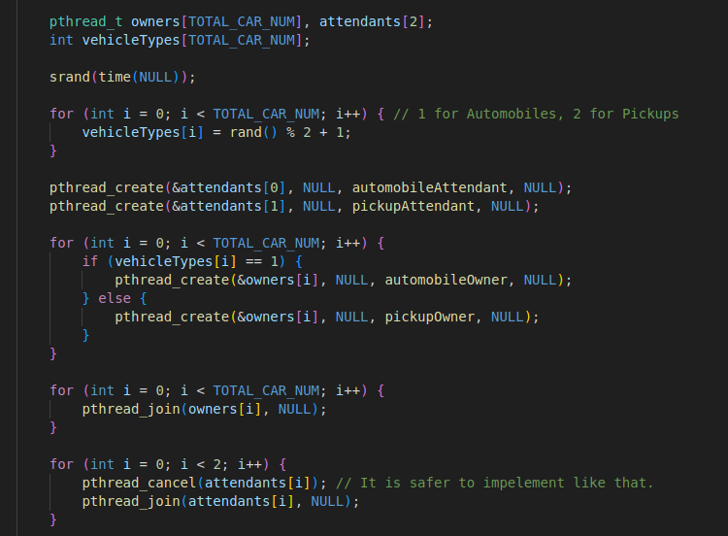

This is the main function. Car array a.k.a vehicleTypes is filled with random numbers between [1,2]. 1 stands for automobiles and 2 stands for pickups.

You can change the total car number at the beginning of the file by changing TOTAL_CAR_NUM macro.

Attendants threads will be created first and then the carOwner threads will be created according to the types of the cars in array. Then program will wait for carOwners to finish but attendants cannot finish on their own. They need a signal to finish and that signal is the killing their threads.
Of course without the end of the carOwners they cannot finish. But it is fine because their finish is after joining the owners’ threads.
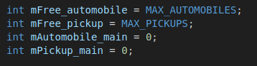

These are the global variables for all therads to use. mFree_automobile and mFree_pickup are representing the empty spaces in temporary parking lot.
mAutomobile_main and mPickup_main are representing the full spaces in main parking lot.

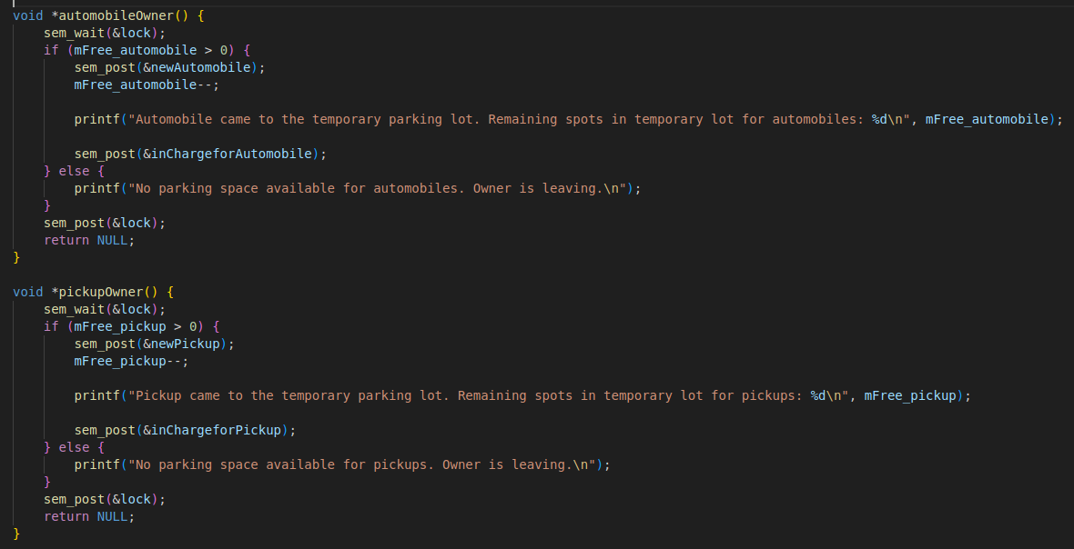
These are the carOwner threads. They first lock the system for themselves and check the available spots in temporary parking lot. If there is a space for them, they signal the valet and the available space count in temporary space will be decreased by one. Then the thread prints the rest of the available spots number. Then notifies the corresponding valet.

If there isn’t a space for them, they will leave.

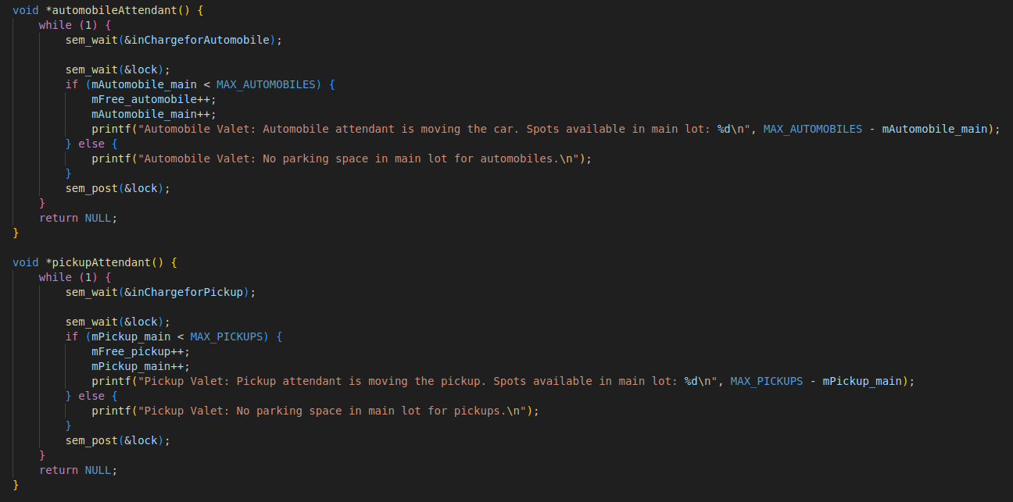
Attendants are waiting for their type of cars to come into the temporary parking lot. When a car shows up, they lock the system and checks the available spot number in main parking lot. If there is a space, they increments the number of available spots in temporary parking lot and the number of the taken spaces in main parking lot because they will put the car in a second. If there is no space in the main parking lot, they are leaving the cars in the temporary parking lot.

- Test Cases

30 Automobiles:
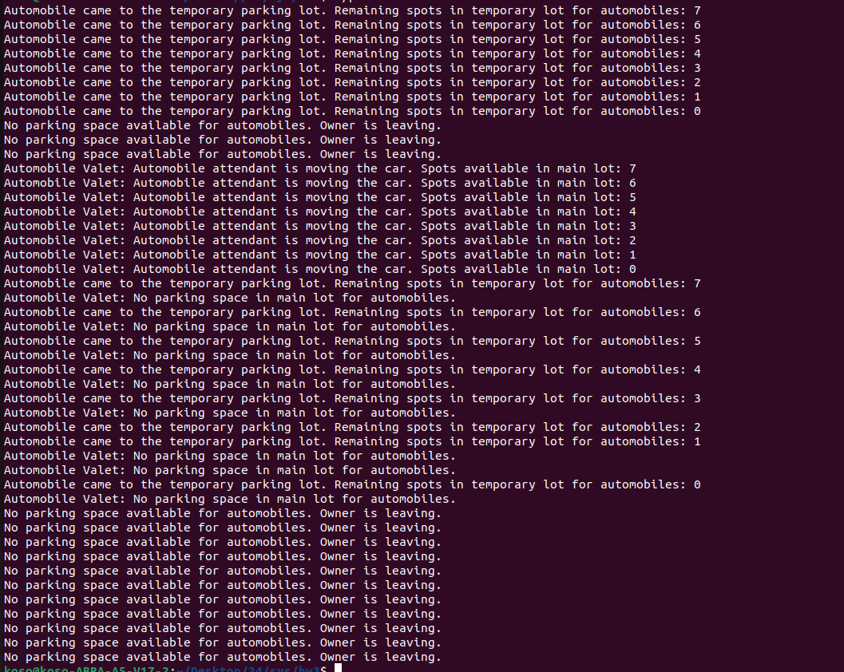
First 8 automobiles went into the temporary parking lot.
Next 3 couldn’t get in because valet wasn’t fast enough. So they left.
Valet moved the automobiles to main parking lot. There is 8 spaces for automobiles in temporary park space right now.

8 more automobiles came to the temporary parking space but valet couldn’t move them.

There is no space in main nor temporary parking space right now. So the rest of the automobiles left.

500 Automobiles:
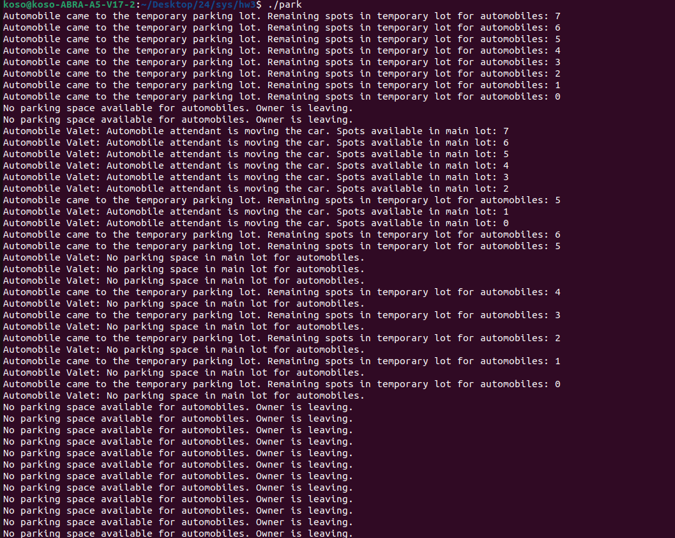
Same scenario as the 30 Automobiles but I wanted to show that it works.

8 Automobiles and 4 Pickups:
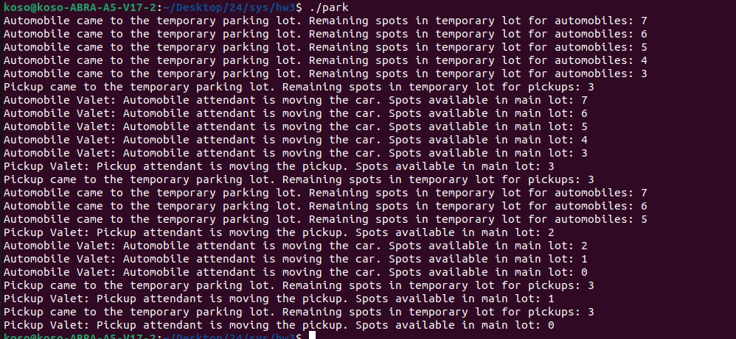
At the end the number of the available spaces in main parking lot is 0 for both type of cars.

16 Automobiles and 8 Pickups:
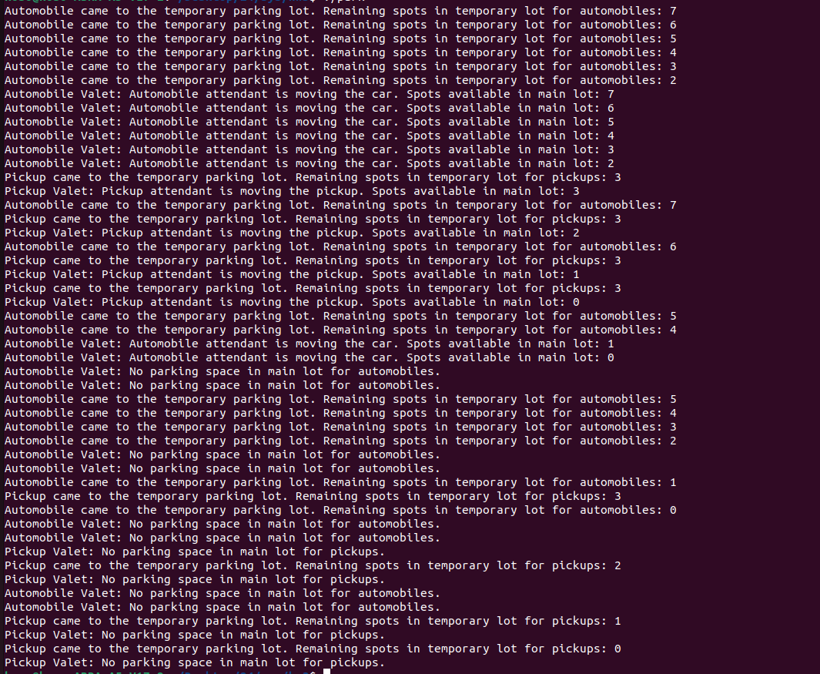
Perfect behaviour was 8 automobiles and 4 pickups in main lot. And 8 automobiles and 4 pickups in temporary lot. But because the speed of the valets some of the cars came and saw that there isn’t space in temporary parking lot (Because valets couldn’t do it faster than the speed of the new cars coming) so they left.

Random 30 cars:

